**Running iModules–Converge Report Merge Process**

1. **Install Ruby on Windows**

Visit <http://rubyinstaller.org/>

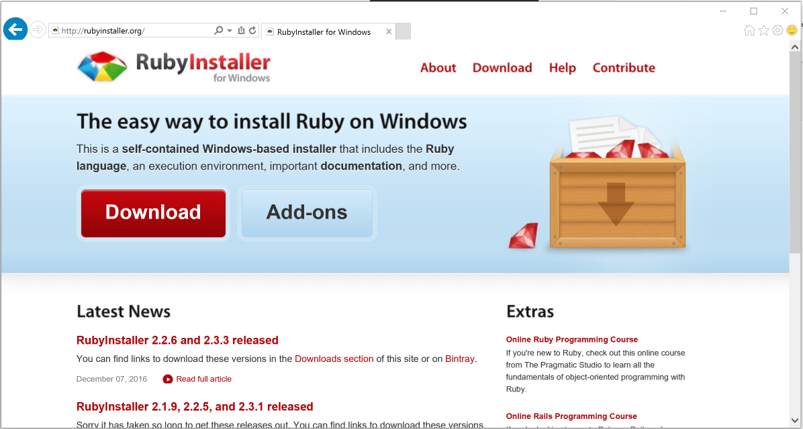

Click “Download”.

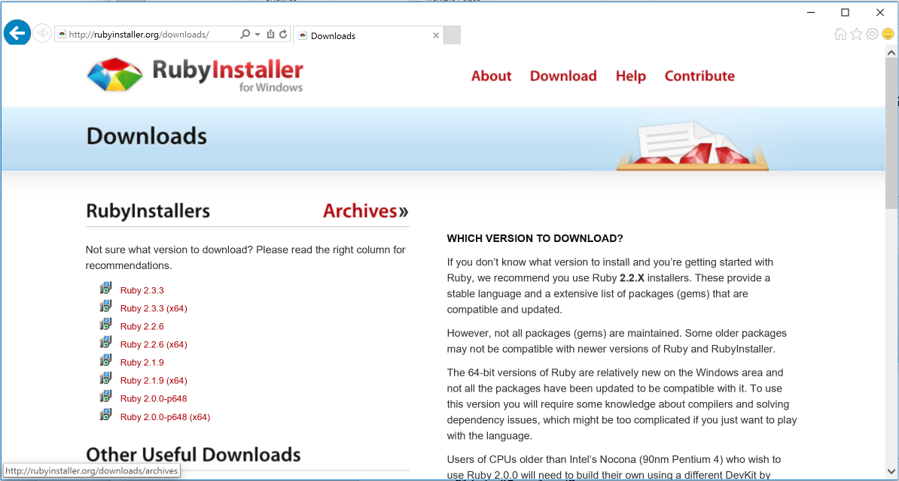

Select “Ruby 2.3.3 (x64)” and run the installer.

Select “OK” for English language.

Accept License Agreement.

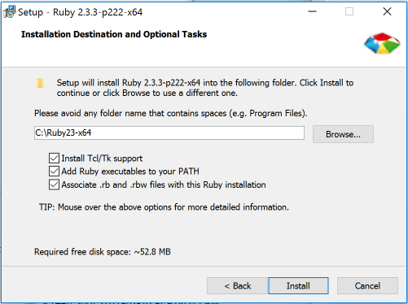

Check all of the boxes and click “Install.”

**Installing scripts:**

Must add “cc-reports” directory containing script “cc-report.rb” inside a directory on C: called “Ruby Scripts”. These directories must be setup manually.

**Running the CC Report process:**

1. Download Converge Batch report, iModules Export report, and iModules Designation report.
2. Open Excel (new spreadsheet).
3. Under “Gift Admin” tab. Click |1| Merge, and select files as prompted.
4. When new spreadsheet appears, click |2| Format.